Knight Times
Palmdale, California — Tuesday, September1, 2015 50 Fifty Cents

Politics
Government is concern that kids are doing our dirty work.

By: Jenny “Too Smart” Smith (302 Words)

Our kids of today are working very hard and everyone at Knight Times feel this is very harsh. Even though kids are very cheap and easy to train it is still wrong. They are proved useful, but if kids are that important, imagine what they could do twenty years from now.
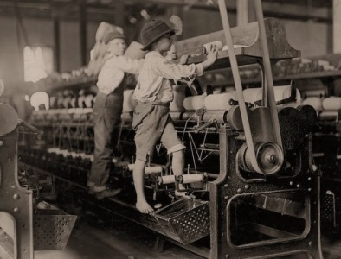
The punishments are very harsh for kids. They get beat very unfairly for simple mistakes. We are all humans and we all have feelings. Kids are worked twelve to fifteen hours per day.In the years that followed the Civil War, known as the “Rise of Industrial America, 1876 – 1900” on the American Memory Timeline of the Library of Congress Learning Page, the United States emerged as an industrial giant. When studying history we see that existing industries flourished and new opportunities developed, such as petroleum refining, steel manufacturing, and the widespread use of electrical power. The use of railroads grew exponentially and industry and services once in isolated areas of the country entered into a national market economy.This era of industrial growth transformed American society creating a new class of wealthy entrepreneurs and a comfortable middle class. The increase in industry resulted in a growth among the blue collar working class. This labor force was made up of millions of newly arrived immigrants and vast numbers of families migrating from rural areas to cities with the hope of job security and prosperity.
With a dream of a better life, rural families relocated to the cities to find work. Sadly, most were disappointed when they arrived and discovered that the truth was not as “Rosey” as they had been led to believe. The jobs available required long hours and offered little pay. In most situations, every able family member was needed to work to simply keep the family above the poverty level.

Economics
Today’s Exciting New Inventions
By: James “The Hiker” Parker (302 Words)

Railroads, steam engines, and factories, these are just some of the great inventions of today. With things such as the spinning and weaving cotton you could get things three times as fast than with hand, such as making clothes. Railroads, powered by coal, helped humans get around by train a lot faster than walking or horseback riding. Steamboats got people across the water without using paddles, and much faster.
These great inventions must be recognized of their creators, some of the worlds all time scientists. Scientist such as John Kay, James Hargreaves, Emund Cartwright, Henry Cort, and Karl Marx. These are just some of the great scientists that made today’s great inventions. Such great things, this will revolutionize our era, and decades to come. With railroads to take us places at high speeds, and machines to take some work off our hands such as weaving cotton, only good has to come.
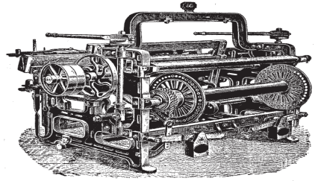
The invention of the steam engine was crucial to the industrialization of modern civilization. For almost 200 years it was the outstanding source of power for industry and transport systems in the West. It prepared the way for the development of more sophisticated heat engines and for the large-scale generation of electricity, which together effectively displaced it from its supremacy in the 20th century.From the introduction of the first viable steam engine by Thomas Newcomen at Dudley Castle coal mine in 1712 to the massive successes of the internal combustion engine in airplanes and automobiles at the beginning of the 20th century, the steam engine was the inspiration of industrialization and its major work-horse.
The steam engine was a complex invention that underwent a process of incremental development which incorporated many important innovations. It was made possible by the increasing understanding of the atmosphere and the nature of a vacuum.

Social& Cultural
Art, food, and music can define theculture of the time.
By: Mary “Mo” Money(301 Words)
The greatest social and economic impact of the agricultural revolution came from the "enclosure movement," in which farmers were able to enclose their fields and grow different crops during different seasons. This drastically changed the centuries old model of the "open field system," in which farmland was used in a semi-public fashion that prevented farmers from growing patterns that differed from traditional ones. This method of farming had been established during a prior agricultural revolution that occurred during the early medieval period. Initially this led to a substantial increase in agricultural productivity.
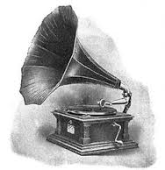
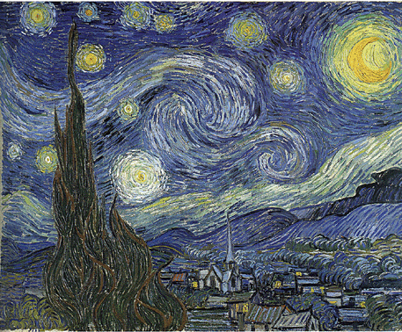
Gradually there was a Malthusian effect; the population increased and the threat of famine reemerged. This reality made the peasants question any proposed changes in the accepted method of farming. Records show that by the middle of the seventeenth century, the price of grain, especially of wheat, increased considerably. The scientific literature of the time stated that production would increase if the land were used in a more structured fashion. Researchers insisted that small, individual peasant plots would become more productive if they were restructured into large agricultural farms. Labor, machinery, fertilizer, and seed would be used more efficiently, thus increasing the bushels per acre. Initially this was met with resistance on the part of the peasants. Eventually, the increase in the supply of food tempered much of the anxiety, and significant changes began to occur within preindustrial society.The reliance on science and technology, the questioning of traditional methods of agriculture, and the centralization of factors of production set the stage for the onset of industrialization.
Also, at this time the traditional peasant-lord relationship began to dissolve. The quest for large profits undermined the bond that once existed between the two classes, and at the same time the gradual acceptance of a market economy began to take root.

Politics
Universal Male Suffrage
By: Mick “Smiley”Jones(296 Words)
The rise of political parties as the fundamental organizing unit of the Second (Two) Party System represented a sharp break from the values that had shaped Republican and Federalist political competition. Leaders in the earlier system remained deeply suspicious that parties could corrupt and destroy the young republic. At the heart of the new legitimacy of parties, and their forthright celebration of democracy, was the dramatic expansion of voting rights for white men.
Immediately after the Revolution most states retained some property requirements that prevented poor people from voting. Following republican logic, citizens were believed to need an economic stake in society in order to be trusted to vote wisely. If a voter lacked economic independence, then it seemed that those who controlled his livelihood could easily manipulate his vote.
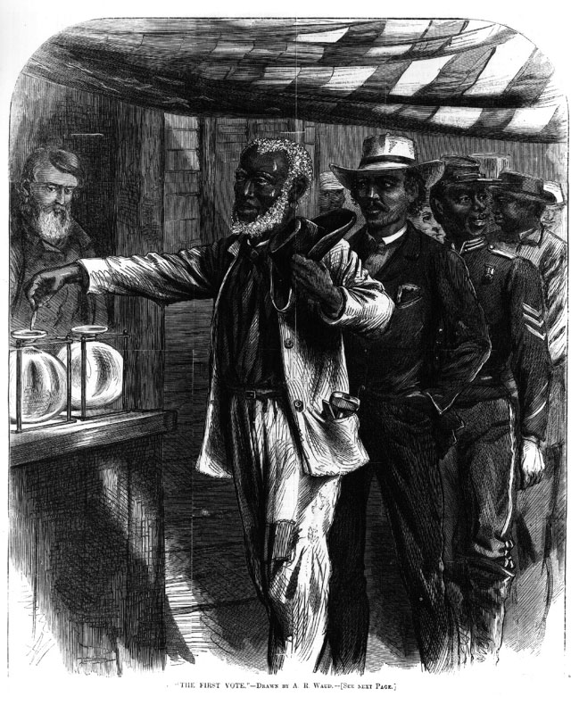
Ironically, just as industrial wage labor began to create dependent laborers on a large new scale, the older republican commitment to propertied voters fell out of favor. As property requirements for voting were abolished, economic status disappeared as a foundation for citizenship. Not only that, voters could now cast their opinion for more offices. Previously, governors and presidential electors had usually been selected by state legislatures as part of a republican strategy that limited the threat of direct democratic control over the highest political offices. The growing democratic temper of the first decades of the 19th century changed this and increasingly all offices were chosen by direct vote. The United States was the world leader in allowing popular participation in elections. This democratic triumph, however, also had sharp limitations that today seem quite shocking. At the same time that state legislatures opened suffrage (that is, the right to vote) to all white men, they simultaneously closed the door firmly on white women and free African Americans.
Reference
Bernstein, M. (2002). Using Active Learning to teach English. Retrieved from http://www.Learning_English_activell.com/articles/

Ellis, E., Esler, A. (2007). World History, the Modern World. Prentice Hall, Boston, MA.

Lapsansky-Werner, E., Levy, P., Roberts, R., Taylor, A. (2008). United States History, Modern America. Prentice Hall, Boston, MA.

